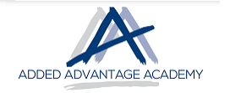

Stand Alone Courses Offered to Corporates, SME’s and Private

- Touch Typing
- Introduction to Computers
- Introduction to Windows
- File Management
- Internet and Internet Mail
- Ms Outlook
- Ms Word
- Ms Excel
- Ms PowerPoint
- Ms Access
- Ms Projects
- Pastel Bookkeeping
- Pastel Processing

- Adobe
- Illustrator
- Photoshop
- InDesign

- HTML
- Introduction (3 days)
- Intermediate (3 days)

- ASP.net and SQL
- Introduction 4 days
- Intermediate (5 day)

